DC Stream Generation
Steps to be followed when a new DC stream to be added:
- Create a header file that has the structure details of the new stream and define required macros (refer existing .h files in DC_SIL->sil_component_streams->A5)
- Run StreamGenerator tool (DC_SIL->sil_component_streams->Tools)

Run STREAM_GENERATOR_5_6_1.exe in STREAM_GENERATOR_5_6_1 2 1 6 folder
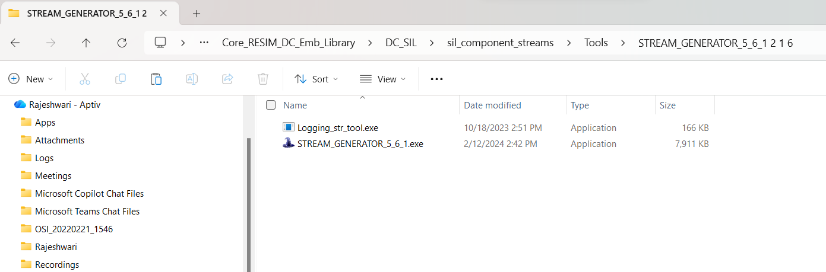

Once it loads, it asks for OS confirmation. Select No
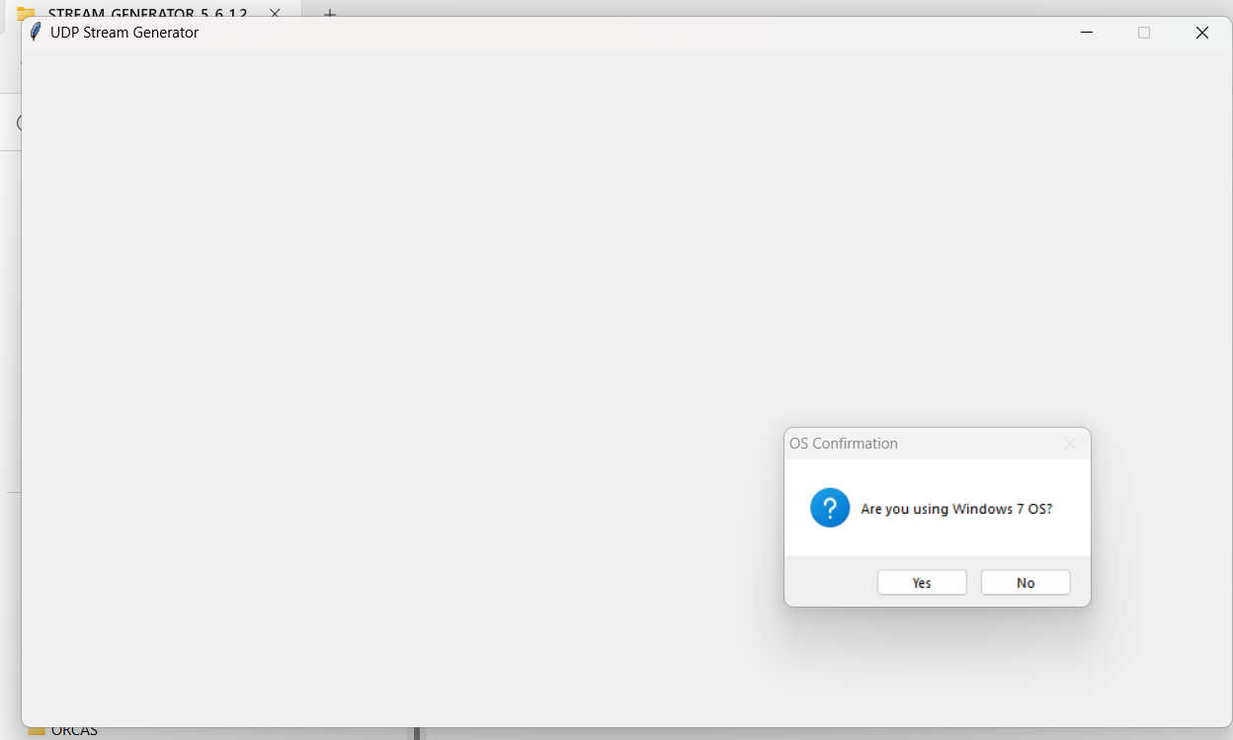

After confirming, select Single stream and then click on Browse/OK to provide the path of header file of the new stream, then click NEXT
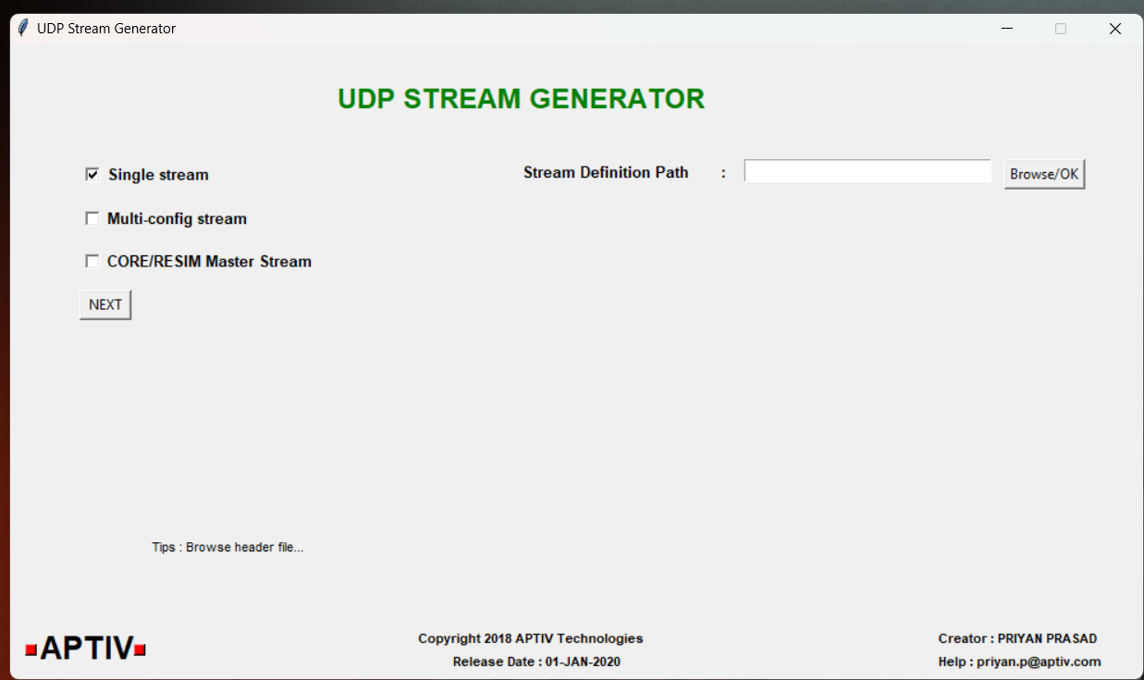

Then it asks for all these details as shown below, but its not needed to provide any of these, just click on ADP Stream Update
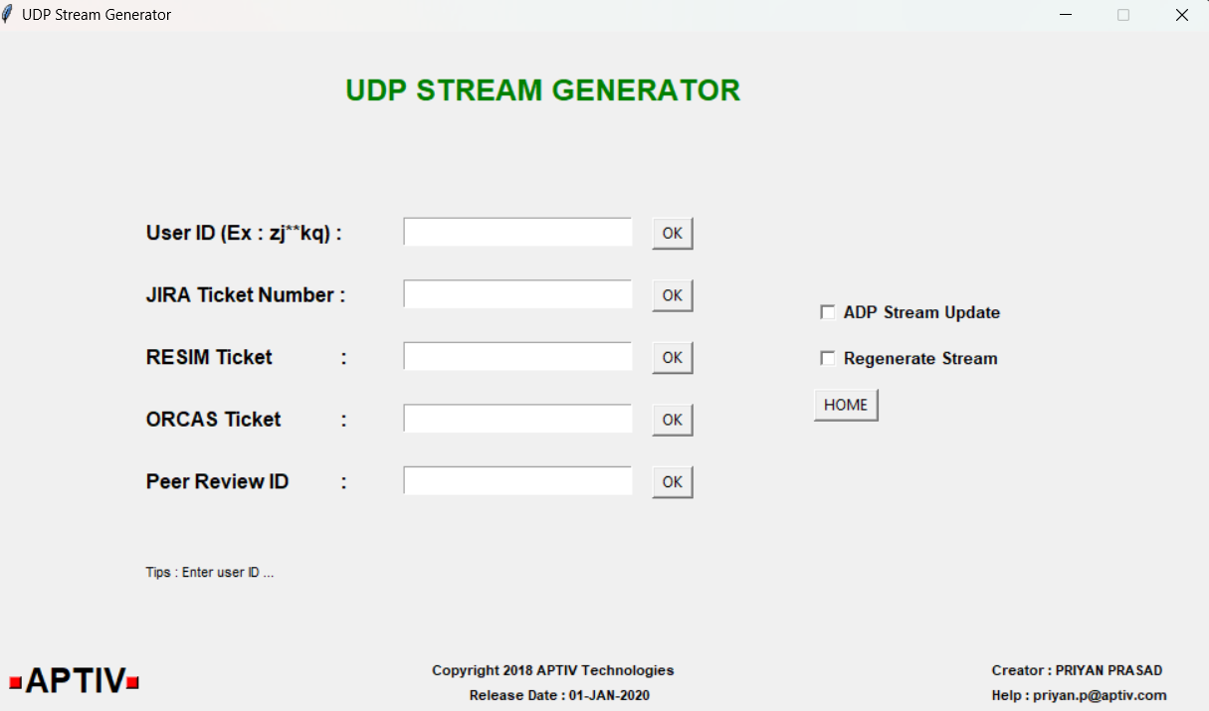

Click on START
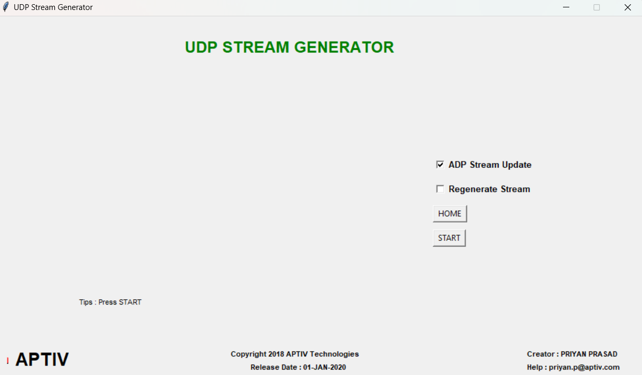

This application internally calls Logging_str_tool.exe
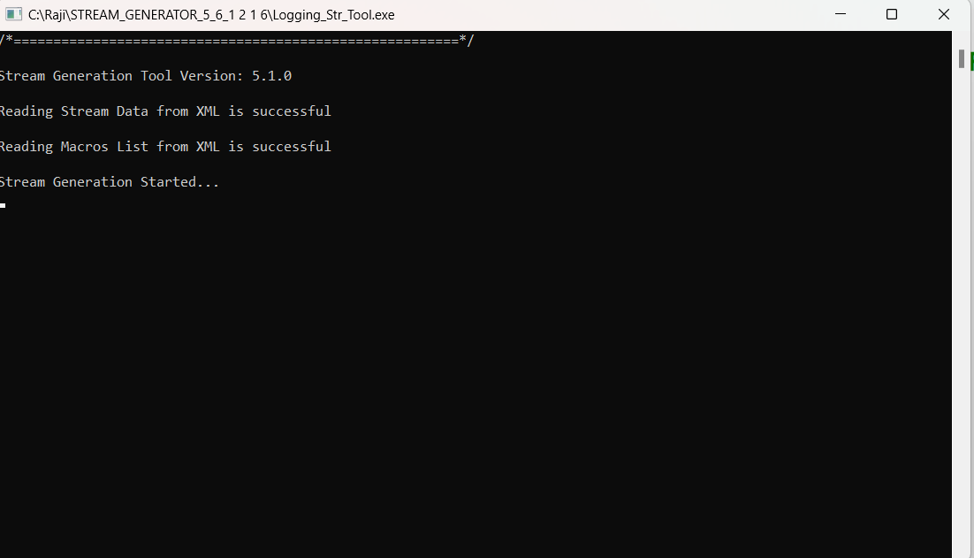

After few seconds, stream generation gets completed.
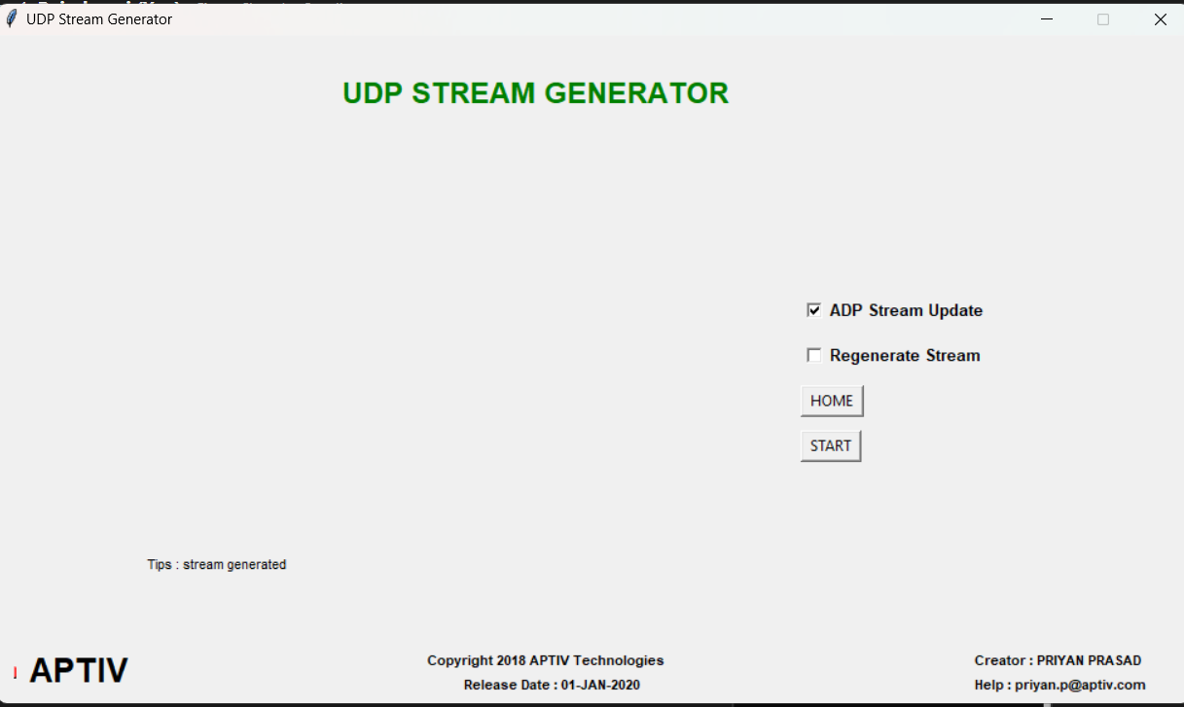

Along with updated .h file , other files also get generated which should be deleted and not to be checked in.
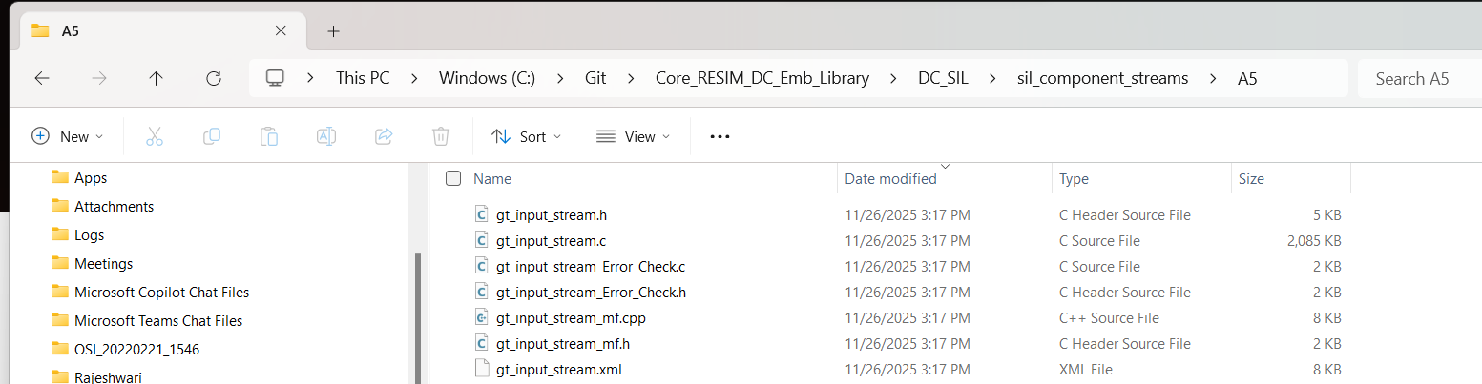

Verify if the .h is proper and size of the structure in header file can be verified by checking with sizeof(structure name).
- Populate the new stream structure variables with the corresponding output in .cpp file
- In stream_handler.cpp, include the new .h file and make the below changes

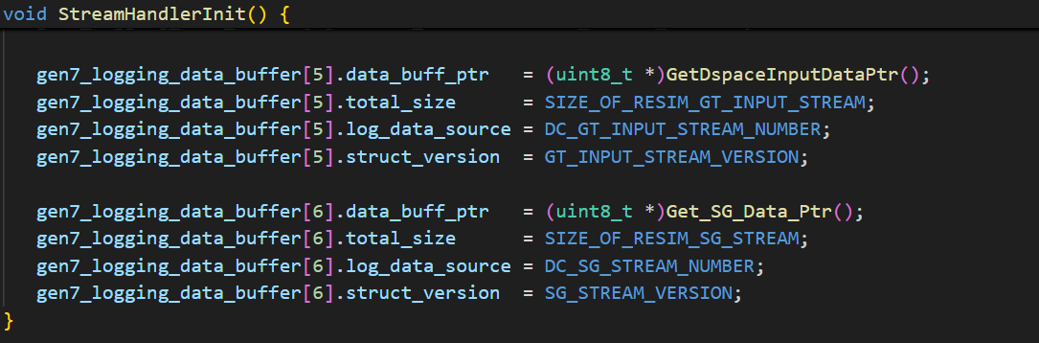

- In siloutput.cpp make the below change (adding function call in TransmitMUDPStreams)
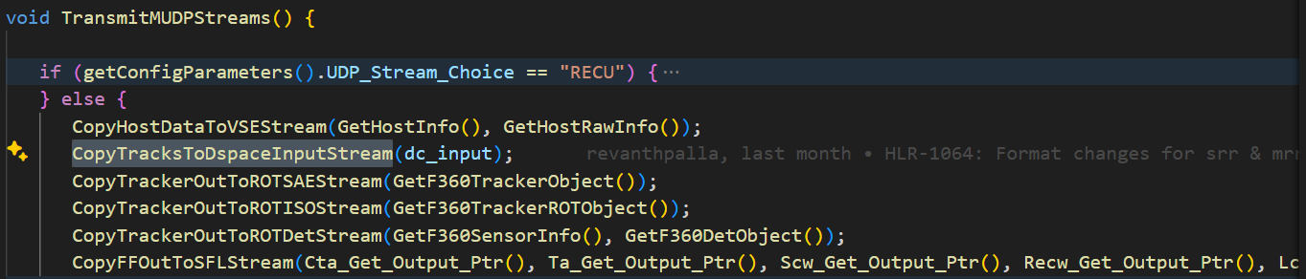
- Validation
- Once output MF4 gets generated with new stream data, take the stream dump by running ORCASFileHeaderDump.py ( DC_SIL->sil_component_streams->Tools)
- Provide the path of Output MF4 as input to ORCASFileHeaderDump.py
- Stream dump csv is generated in the same folder that has Output MF4
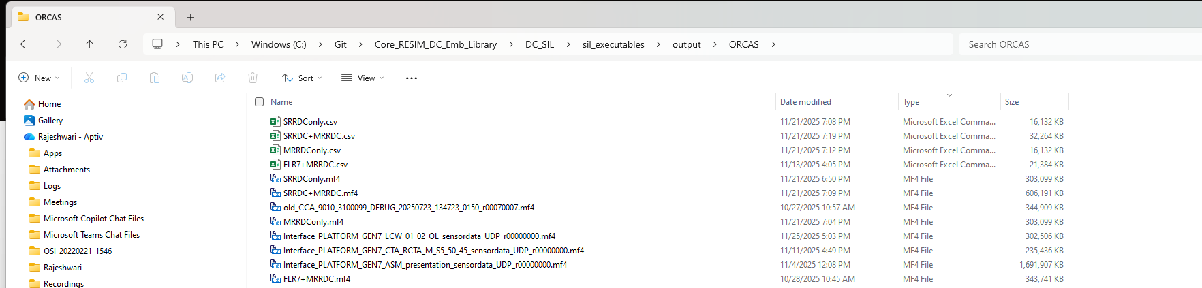

- Verify if stream chunks of the new stream are correct by comparing it with packets.
Packets = (uint16_t)((((uint32_t)SIZE_OF_NEW_STREAM) / ((uint16_t)REC_PAYLOAD)) + 1)
For example, Packets for GT stream = (80008/1444)+1 =56 and stream chunks are 0x38 which is 56 in decimal.

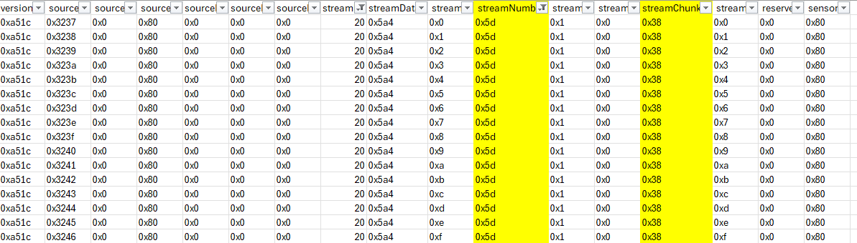

- Verify stream chunks for few random scanindices and check other columns data as well like if the sensorId is proper.
- Raise the request to ORCAS team for visualization of new stream by sharing the header file , output logs and provide required information.

